Name of the Textbook: Glencoe World History
Grade Level of Target students: 9th Grade World History Students
Title of Chapter or Selection: Chapter 16: The East Asian World 1400-1800
Length of Selection: 22 pages (including 2 intro pages with limited text and 2 concluding pages with review activities)
Estimated Reading Time required: 45-60 minutes

1. Pre-reading Activities
Content Analysis
Major Concepts Content Topics
▪ Pre-Imperialism ▪ How China & Japan react to the arrival of
▪ Chinese Dynastic Change Europeans
▪ Tokugawa Japan ▪ Governmental Structure of Japan
▪ Flourishing of East Asian Culture ▪ Role of the family in China and Japan
▪ Artistic flowering and how it relates to
trade
▪ How Europe reacts to China and Japan

Visual Aids Organizational Patterns
▪ Maps and Pictures in Textbook ▪ Chronological
▪ Pull-down World Map ▪ Cause and Effect
▪ Vocabulary Digital Stories ▪ Categorical
▪ Graphic Organizers ▪ Biographical
▪ Museum Websites ▪ Compare and Contrast
▪ Museum Catalogs
▪ Art Magazines

Skills Needed Objectives/Students will be able to:
▪ Note Taking with Organization ▪ explain the difference between Ming/Qing dynasties
▪ Analytical Reading ▪ outline class system in Tokugawa Japan
▪ Inference ▪ explain how the arrival of Europeans changed life in
▪ Synthesis/Big Picture formation China/Japan
▪ Questioning ▪ describe the role of women and what family life was like
▪ illustrate how changing cultural elements indicated the
changes occurring within the country
▪ locate the roots of Imperialism within this time period

Resources for Motivation and Background
This is the beginning of Imperialism, which has results on political and economic systems and relationships even to this day. It advances knowledge of the region first developed in Chapters 3 and 8 of the textbook. Students may have previous knowledge or ideas about the era thanks to martial arts movies and anime.
VOCABULARY

Persons Places Technical Textbook Key Terms
Ming Nanjing Great Wall queue
Zheng He Portugal centralized bureaucracy banner
Li Zicheng Guangzhou civil service commercial capitalism
Manchu Macao missionaries clan
Qing Beijing martial arts porcelain
Kangxi Manchuria White Lotus Rebellion daimyo
Qianlong Imperial City province han
Cao Xuegin Kyoto Confucianism hostage system
Yong Le Osaka footbinding eta
Oda Nobunaga Edo novel
Toytomi Hideyoshi Nagasaki Forbidden City
Tokugawa Ieyasu Korea tenant farmers
Francis Xavier Hanyang shogun
samurai
ronin
kabuki
Anticipation Guide
Directions: Read each statement. Indicate if you think it is TRUE or FALSE on the left column. After reading, indicate whether the statement is TRUE or FALSE and what page of the textbook supports this.
True/False BEFORE reading | Statements | True/False AFTER reading | Page(s) in textbook supporting your answer
 | Early Ming Dynasty China expanded Chinese territory and made peace with the Mongolian tribes north of the Great Wall.
 | The ships of exploration that left China under Zheng He were over five times bigger than the ships Columbus used to sail to America..
 | The first European country to contact China since Marco Polo visited was Spain.
 | The Manchus, who founded the Qing Dynasty, were of a different ethnic and cultural background from the rest of China.
 | The British were content to accept the trading restrictions placed on them by China and did not demand more access to Chinese cities.
 | The first major cause of Chinese economic change was population decline.
 | The Chinese government controlled trade and manufacturing, not private citizens.
 | The ideal family unit in Qing China was the extended family, which included 3-4 generations living under one roof.
 | The practice of footbinding made women with bound feet less desirable for marriage and resulted in lower status.
 | The Imperial Palace in Beijing was also called the Forbidden City because commoners were not allowed inside.
 | There were four major political figures who unified Japan in the late sixteenth century.
 | Missionaries converted thousands of Japanese to Christianity in the 1500s.
 | Merchants formed the lowest level of the 4-tier class system in Tokugawa Japan.
 | Due to morality concerns, only actresses are allowed to appear in Kabuki plays.
 | Korea, also called the Hermit Kingdom, had minimal contact with Europeans from 1400-1800.
II. During Reading Activities
Vocabulary Digital Story
I chose the words daimyo, han, Edo, shogun, hostage system, samurai, and eta for my vocabulary digital story. I wrote the story of Kenji, the young son of the daimyo of Asada han. These words were defined in the story when Kenji travelled from his father’s han in Asada to the capital of Japan, Edo, as part of the practice of the hostage system. This digital story only covers the third section of a three part chapter unit. I would ideally prepare two more digital stories to cover the other two sections. These three digital stories would be played on the chapter introduction day, with different learning activities interspersed between each digital story to give students a chance to both absorb content and to focus on each of the three sections as individual subgroups within the chapter. Because of the way the content is sub-divided, it would also be easy to have students read each section on its own rather than the chapter as a whole but for the purposes of this study guide, the assumption will be that students will read the chapter in its entirety rather than in sections. Students could potentially use the digital stories for review at the end of the chapter prior to the test as I would make the digital stories available online. Lastly, I could incorporate the digital stories into some after-reading activities to help students synthesize the material.
In terms of what I would do for the other two sections, I would create the following digital stories: The first section covers the Ming and Qing dynasties and the beginnings of European trade. I would tell the story of Ying Li, a Chinese teenager studying for the civil service exams in Qing China. Ying would be studying history as part of his preparation so I could include terms relevant to the Ming dynasty as well as the Qing. The words I would include are Ming, Beijing, Yong Le, Zheng He, Macao, Manchu, Qing, queue, banners, Kangxi, and Qianlong. Frankly, there is a lot of information in this one section, so potentially it would need two stories – one focused on the Ming dynasty and one on the Qing dynasty – to keep from having too much material in a single video. For the second section, which discusses changes in Chinese culture and society during the Ming and Qing dynasties, I would tell the story of Fang Chen, a young woman preparing for marriage in the late eighteenth century. The words I would include are footbinding, clan, Confucianism, commercial capitalism, porcelain, Emperor Yong Le, novel, and Cao Xuegin. In terms of all sections, words covered include the key terms the textbook highlights as well as other terms I consider important to comprehend the content.

Comprehension Activity
CARI – Content Area Reading Inventory
Directions: Please read pages 488 – 490 in your textbook, starting from the heading: The Qing Dynasty. Do not read the ‘The Way It Was’ section on Sports & Contests. Before you start reading, make note of the time you see on the clock at the blackboard. As soon as you are finished reading, look at the clock again. Calculate how long it took you to read the selection and record this time on the space provided on this worksheet. Then, close your textbook to answer the first question. Once the first question is answered, you may re-open your textbook to complete the remaining questions.
Reading Time: ______________ minutes ________________ seconds
Section 1: Close your textbook and then answer the following question on the back of this worksheet. What was this selected reading about? Answer in your own words.
Section 2: Open your textbook and answer the following questions.
- To identify rebels, the Manchu government ordered all men to adopt Manchu-style hairstyles, which meant shaving foreheads and braiding hair into a style called a ‘queue.’
- True b. False
- Manchus made up only one percent of the population so they tried to blend in with everyone else and not be seen as separate from the rest of the Chinese people.
- True b. False
- Emperor Kangxi, perhaps the greatest ruler in Chinese history, was quite tolerant of Christianity.
- True b. False
- The White Lotus Rebellion was launched in response to religious pressure.
- True b. False
- Emperor Qianlong wrote to King George III of Great Britain to tell him that China had no need of British manufactured goods.
- True b. False
Section 3: These questions are not directly stated in the text. You must ‘read between the lines’ to answer them.
- What methods or actions did the Manchus of the Qing dynasty use to become accepted rulers of China?
________________________________________________________________________
- How were the Jesuit missionaries’ efforts at conversion different from those of other Christian missionary groups?
________________________________________________________________________
- Give two examples of pressure on the Qing government to open China to more trade.
________________________________________________________________________

Section 4: These questions are not directly stated in the text. You must ‘read between the lines’ to answer them. Think carefully about the material you have read to arrive at your answers.
- Think about ways in which the Manchus remained ethnically and culturally distinct from the rest of China. How would these actions have helped them maintain power?
________________________________________________________________________________________________________________________________________________
- Why do you think missionary activities would have gradually been restricted in China?
________________________________________________________________________________________________________________________________________________
- The text says “The Chinese would later pay for their rejection of the British request.” What do you think this means with regards to what you currently know about the British trade with China?
________________________________________________________________________________________________________________________________________________

Graphic Organizer 1
After reading section one of the chapter – China at Its Height – complete the following graphic organizer. Rotate page for ease of use.

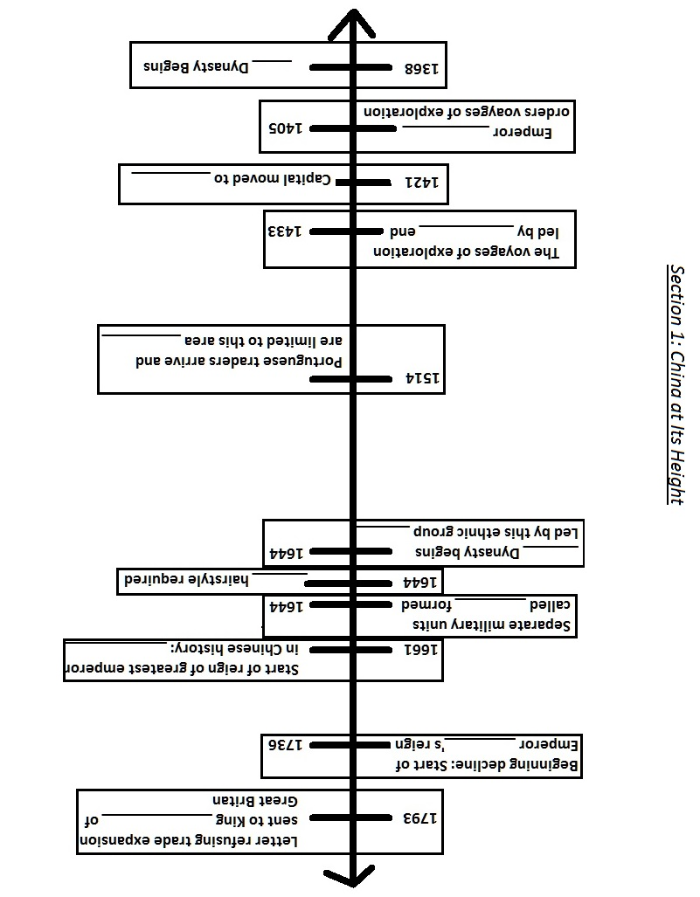
Graphic Organizer 2
After reading section two of the chapter – Chinese Society and Culture – complete the following graphic organizer. Vocabulary words are already included. Be sure to define them and to include additional details about each subtopic on the lines provided.

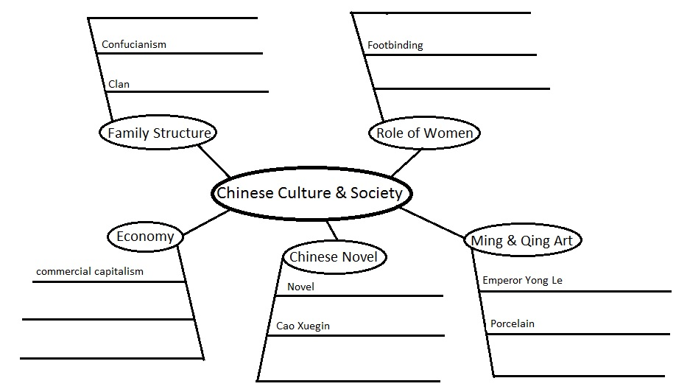

Graphic Organizer 3
After reading section three of the chapter – Tokugawa Japan and Korea – complete the following graphic organizer. Be sure to complete both elements.

Fill in the below chart describing the hostage system.
If the Daimyo is…. | …Then his family is….

Next, complete the below chart outlining the structure of society in Tokugawa Japan.

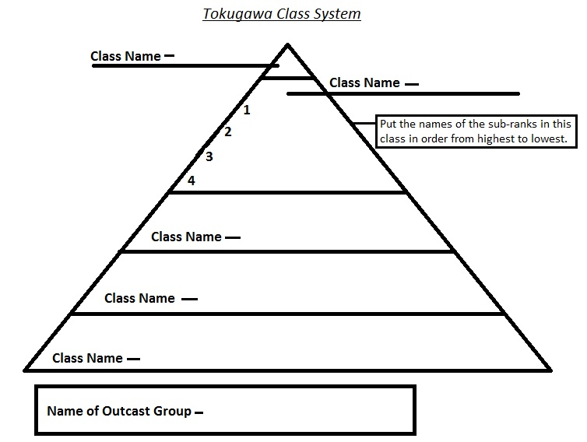

III. After Reading
All students must complete Activity 1 – Unsent Letters. Then, choose 1 activity to complete on your own and 2 activities to complete with a partner.
Activity 1 - Unsent Letters: Pretend you are a merchant or a missionary from Portugal who has travelled to China or Japan. Write a letter home describing what you have encountered. Be sure to indicate what country you are visiting, what year it is, who and what political system is in place, what trade goods are available, where you are able to trade within the country, what the society is like – class and family structure, the role of women, and any significant cultural activities or artifacts you encounter. Illustrate how you are treated by those you encounter and what you hope to gain from your visit. What impresses you and what disturbs you? Be creative and describe the sights, sounds, and smells. Imagine what it would be like to land in China or Japan after a long sea voyage from Portugal. If you are a merchant, be sure to include extra details about economic concerns. If you are a missionary, be sure to include extra details about religious and cultural concerns. Feel free to include doodles or drawings to supplement your letter.
Choose 1 of the following to complete alone.
Activity 2 – Biography: Write a biography of 1-2 pages in length of one of the rulers/political leaders encountered in the text. Make sure you emphasize why these people are important and should be included in the textbook. Please cite at least 2 sources aside from the textbook.
Activity 3 – Poetry: Following the rules of haiku (5 syllable line, 7 syllable line, 5 syllable line), write at least five poems that define/explain/interpret a vocabulary word from the chapter. Be as creative as possible. Please use the vocabulary word itself as the title for your haiku.
Activity 4 – Art: Blue and white porcelain was a major trade object between China and Europe. On the provided worksheet, illustrate the plate using blue ink and white space in a way that you think best illustrates daily life in Qing dynasty China. At the bottom on the provided lines, explain what you chose to illustrate and why.
Activity 5 - Interview: The textbook includes a short piece about martial arts as an extra for the chapter. Read this excerpt found on pages 488-489 to gain some background information. Then, find a local martial arts school in the area and interview the instructor. Be sure to find out what tradition the school practices, its philosophy, where the martial art originated, what it takes to become a master or instructor, and what sort of skills are emphasized. Put the information from your interview into either paragraph or question-answer format.
Activity 6 – Chapter Assessment & Activities: Complete the following activities found at the end of the chapter on pages 502-503. Complete questions 1-19 and 25-27.

Choose 2 to complete with a partner. You can use a different partner per activity.
Activity 7 – Timeline: Create an integrated timeline illustrating important dates and figures from the text across all three sections. Be sure to highlight any locations, people, or terms that are on the vocabulary list. Include relevant images or illustrations that you locate online.
Activity 8 – Webquest: Using the computer lab, complete a webquest on one of the following eras: Tokugawa Japan, Ming Dynasty China, Qing Dynasty China. Be sure to fulfill all activities for the webquest to receive full points.
Activity 9 – Economics: Research the vocabulary term ‘commercial capitalism’ in more depth utilizing the internet and the school library. Write three paragraphs that explain why commercial capitalism did emerge in Europe but not in China. Provide examples of commercial capitalism in Europe during the date range of 1400-1800. Decide if you think the different economic models in Europe and China will cause conflicts and explain how and in what ways you think this might occur.
Activity 10 - Skit: With your partner, create a short skit (no more than two minutes in length) that illustrates an element of life in East Asia during the years from 1400-1800. You can choose to include an encounter with Europeans, aspects of family life, elements of culture, the role of women, or major events such as rebellions or dynastic change. Record your dialogue on a piece of paper and then write 1-2 paragraphs explaining what your skit is about and how that relates to life in East Asia. The paper will be turned in and you will perform your skit for the class.
Activity 11 - Korea: The textbook doesn’t really look at events in Korea. Spend some time researching the history of Korea from 1400-1800. Come up with a list of at least five vocabulary words you think are important to know, five historical figures you think are important to know, and at least three locations that you think are important to know. Include specific dates where relevant. Create a handout that you can share with the class that defines these terms and explains why you think it is important for the class to have this information.
Activity 12 – Storybook: Create an illustrated short story of 8-12 pages in length that you could read with a second or third grader. The story should illustrate an element of content covered in the chapter. For example, you could tell the story of the voyages of Zheng He, trade with Europe, or the establishment of the Tokugawa shogunate. Make sure your language is appropriate for the grade level and be inventive with your illustrations and story-telling technique.
Activity 13 – Vocabulary Digital Story: Rewatch any of the three vocabulary digital stories. Then, using the character of the story, create your own 2-3 minute video that shows either 1)What happens next for the character – be sure to incorporate additional vocabulary and information from the text or 2)Go in-depth – choose an element of the existing story and go into more detail, such as elaborating on Fang’s experience with footbinding or Kenji’s encounter with the eta. Be sure to incorporate additional vocabulary and information from the text. The video will be shared with the class.
IV. Evaluation Plan
Whole Study Guide Rubric
Notes: Rubrics for each of the After-Reading Activities will be made available outlining how points are to be earned.
Activity | Possible Points | Comments | Points Earned
Anticipation Guide – each question 0.5 pts with 2.5 supplemental. | 10
CARI Activity – each section is wroth 2.5 pts | 10
Section 1 – China at Its Height - Graphic Organizer | 20
Section 2 – Chinese Society & Culture - Graphic Organizer | 20
Section 3 – Tokugawa Japan & Korea - Graphic Organizer | 20
Unsent Letters Activity | 100
Independent Activity (choose from Activities 2-6) | 30
Partner Activity #1 (choose from Activities 7-13) | 50
Partner Activity #2 (choose from Activities 7-13) | 50
Participation | 40
Chapter Test | 100
Total Points | 450

Activity 1 – Unsent Letters Rubric
Notes: In order to receive full points, all elements listed must be present in the letter. I expect your letter to be at least one full page but likely longer to include all the required elements. Feel free to be creative in your choice of whom you are writing to. Casual language is acceptable if it is fitting for the person you are addressing, ie if you are writing to your mother as opposed to an employer or boss. Feel free to include small drawings or doodles or even ‘snapshots’ (Yes, this is an anachronism) if you feel more comfortable using images from the web rather than creating them yourself. If you do use web images, be sure to include a source link for each image at the end of your letter. To fully cover each ‘description’ element, be sure to include a MINIMUM of three pieces of information for each. More is highly encouraged.
Elements Included | Possible Points | Comments | Points Earned
Indicated Country, Date, and Role | 5
Description of government/political system | 15
Description of goods available for trade | 10
Description of social classes/society | 15
Description of role of women | 10
Description of cultural activities/artifacts | 10
Role-specific concerns/details: Merchant/Missionary | 20
Creative Aspects, such as overall details, pictures, tone, character development, description. If using web images, sources provided. | 10
Spelling and Grammar | 5
Total Points | 100

Activity 4 – Art: Performance Evaluation Rubric
Notes: Please use the provided blank plate worksheet and use only BLUE ink/colored pencil/paint/crayon/marker. If you need a blue utensil, please see me. You are to illustrate an element of daily life in Qing Dynasty China. Make sure you include details that will clearly indicate that this is the Qing Dynasty. There are books and magazines at the front of the class that you should use to understand the style of ceramics. Please use these as inspiration for HOW you will draw but not WHAT you will draw.
Elements Included | Points Possible | Comments | Points Earned
Illustration is clearly representative of an element of daily life in Qing China (era-specific details included) | 10
Illustration is creative but draws clear inspiration from examples of Qing-era Porcelain provided in class | 10
Illustration is clear – student does not have to be an expert artist but it is reasonably easy for the drawing to be understood – not abstract. | 5
Explanation of illustration is provided and offers relevant reasons | 5
Total Points | 30

New Chapter – East Asia 1400-1800
We will be embarking on a new chapter for the next two weeks of class. The class will be learning about developments in China and Japan during the period from 1400-1800 AD in conjunction with our UNIT focus on The Early Modern World 1400-1800.
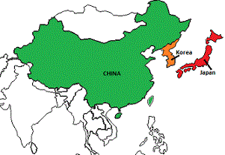
Most students will not have learned much about the history of this part of the world in previous classes so I am looking forward to introducing new information. We will use this to build toward later chapters on Imperialism. Any parents with cultural/social/historical background in this region who is interested in sharing their knowledge with the class, please get in touch with me to arrange an opportunity to come in and work with the class
Cultural sensitivity will also be important. Please be aware that part of our in-class discussions and readings will involve talking about the work of missionaries and the reaction to these missionaries with the region. The class will look at Christian missionaries – in particular the various Catholic orders – and how these groups contributed to events and developments in China and Japan. We will also be discussing Confucianism as a dominant socio-cultural force in China and Japan and contrasting this with missionary teaching. If you have any questions or concerns, please feel free to contact me so we can discuss them.
What We Will Be Doing
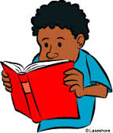
This will be a busy unit! Students will be reading Chapter 16 in their textbook and completing a reading study guide. The chapter is broken into three parts so we will devote separate class days to covering each section.
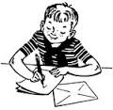
ALL students will also be required to complete the UNSENT LETTER activity. This project requires the student to imagine that he/she is a European merchant or missionary newly arrived in either China or Japan. He/She will write a letter home describing what is encountered in this new country. A rubric has been provided outlining the requirements for this project. It is worth 100 points
Additionally, each student will need to complete an additional individual activity as well as two paired activities to show understanding of the chapter. These activities range from writing haiku poetry to writing a report to completing a short video. Supplemental activities are worth a total of 130 points.
Finally, there will be a Chapter TEST worth 100 points that will test student comprehension of the main elements of the chapter. Total possible chapter points are 450. A breakdown of points and all rubrics is available on the class website.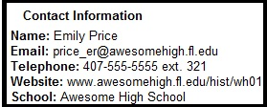

Reflection
The newsletter I composed was a little more difficult than I expected. I really wasn’t sure what was important to include and what was irrelevant. Parents are interested in what their children are learning but are not students themselves so I don’t think including actual factual information is necessarily appropriate. What I did include are the parts that I think are most important for the parents to know: what their children will be learning, required assignments and points, and any potential controversies. Because we will be discussing religion, I thought it was important to point that out in case any parents have questions or concerns that they would want to clear up with me. In addition, I extended an invitation to parents with relevant experiences or knowledge to share with the class, which will increase diversity, provide a sense of inclusion for parents, and bring in a different perspective for the students. By listing the key assignments, parents will also be able to ask their children specific homework questions to help with ensuring their children are on task towards completion and getting all possible points. It is important to include this information as it helps parents to stay involved and to know what’s going on, especially if their teenagers are not very forthcoming. By including contact information – and by uploading rubrics and activity information to a class website – parents will be able to remain informed and will also have a clear understanding of why a student received points for a given assignment and the chapter overall. I tried to include graphics that are relevant but would also provide visual guidance for ESOL parents. The use of selected underlining and bold fonts should also help parents pinpoint key data quickly. Finally, I have included the motivation for including this chapter, which is to gain a new perspective on an area of history not covered as in-depth in schools as well as to build towards later very important chapters on Imperialism. I would hope that I have included enough information to be useful but nothing that would be irrelevant or add to a parent’s burden. I think that such newsletters are a great way to keep parents involved and informed, especially for parents of teenagers as such students may not be as forthcoming about their daily activities.

